10 .Text Box
The TextBox control is used to get the input from the user of the web application. An asp.net textbox has several properties, that we need to be aware of as a developer.
Properties of a TextBox control
1. TextMode Propertry - SingleLine, MultiLine and Password.
When you set the TextMode to MultiLine, use Rows property to control the number of lines to display for a MultiLine TextBox.
2. Text - Use this property to set or get the Text from the TextBox.
3. MaxLength - The maximum number of chatacters that a user can enter.
4. ReadOnly - Set this property to true if you don't want the user to change the text in the TextBox.
5. ToolTip - The tooltip is displayed when the mouse is over the control.
6. Columns - Use this property to specify the width of the TextBox in characters
7. Height - Set the height
8. Width - Set the width
9. AutoPostBack - By default, the TextChanged event of a TextBox control is cached in the viewstate, and is executed when the webform is submitted thru a postback by clicking the button control. If you want to change this behaviour, and post the webform immediately when the Text is changed, set AutoPostBack to true. Setting this property to true, will convert the cached event into a postback event.
Events of TextBox:
TextChanged - This event is fired, when the text is changed.
Methods of a TextBox:
Focus - Set input focus onto the control.
To view the properties of the TextBox, Right click on the control, and select Properties. In the properties window, you can also find the events supported by the control.
All these properties can be set at the design time, or at runtime using code
Single line 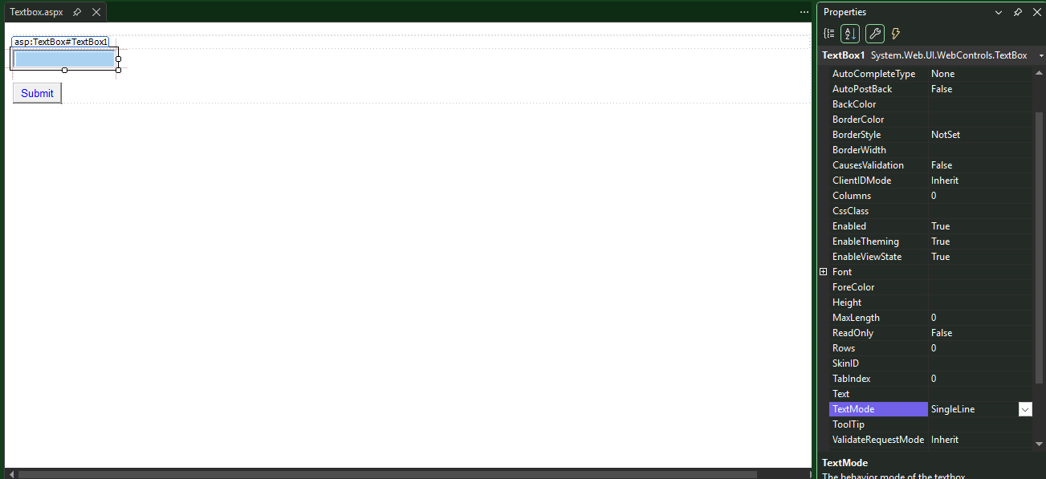
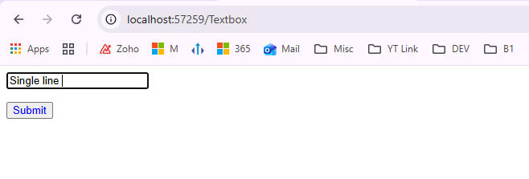
Multi Line
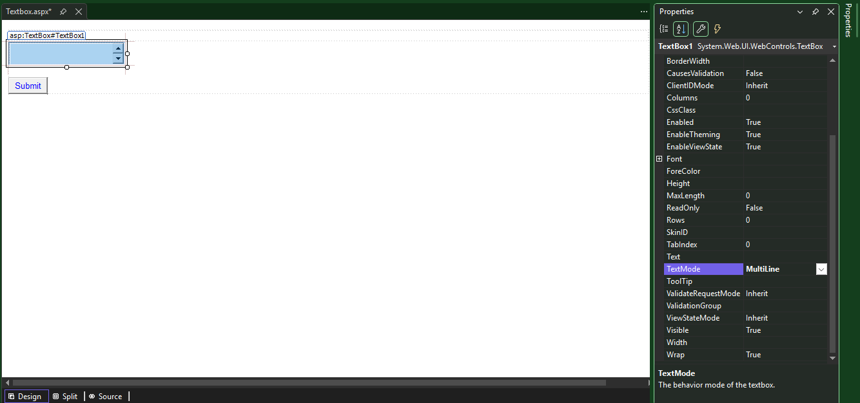
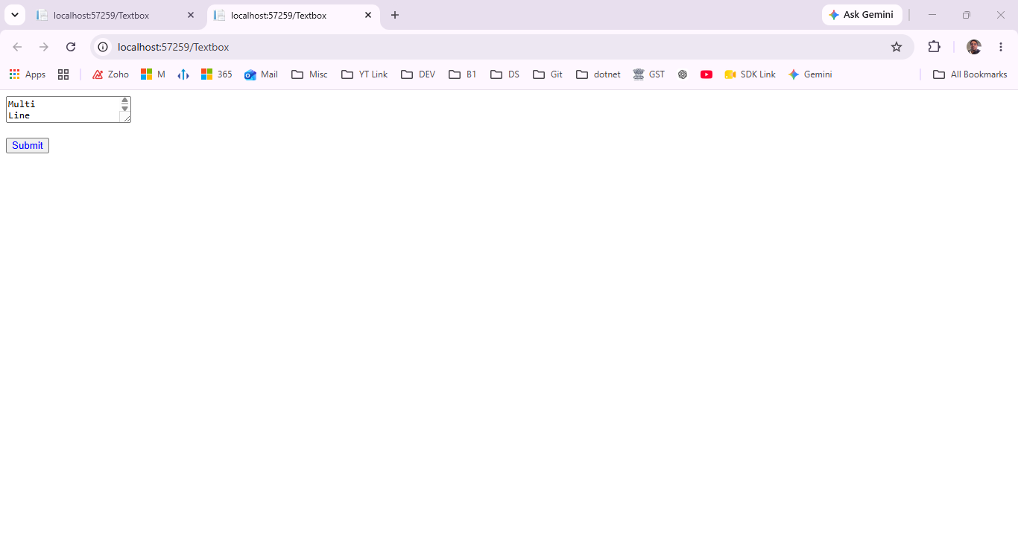
How can define no of row even multi line 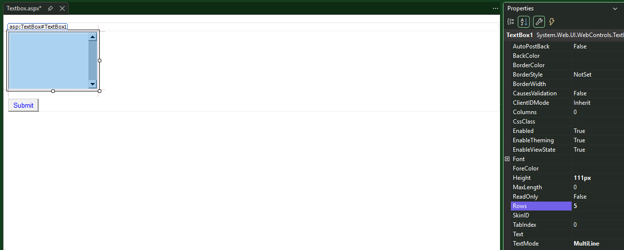
Password mode encrypted the data
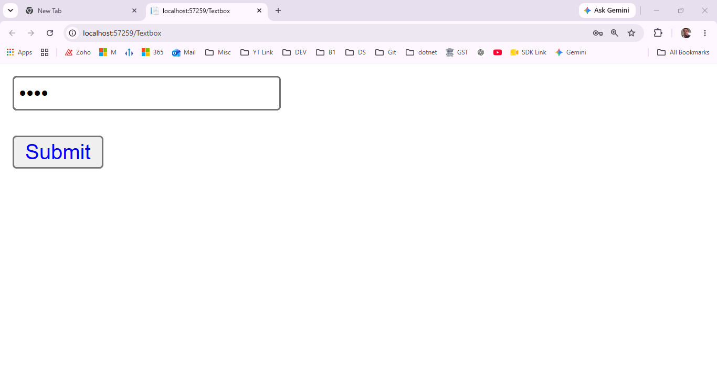
Define if any this type in text box return in response
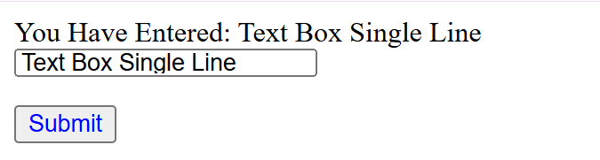
namespace WebForm1
{
public partial class Textbox : System.Web.UI.Page
{ protected void Page_Load(object sender, EventArgs e)
{
}
protected void TextBox1_TextChanged(object sender, EventArgs e)
{
}
protected void Button1_Click(object sender, EventArgs e)
{
Response.Write("You Have Entered: " + TextBox1.Text);
}
}
}
Tooltip
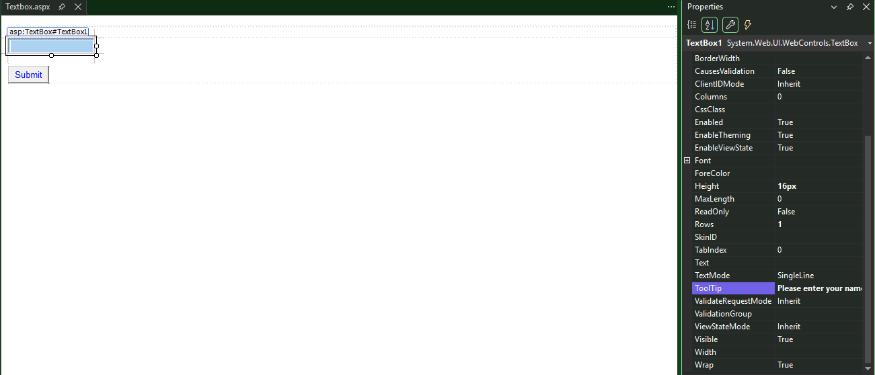
AFTER HOVER ON FIELD
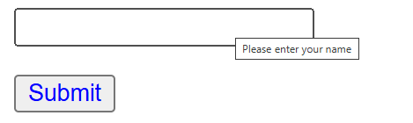
Auto postback
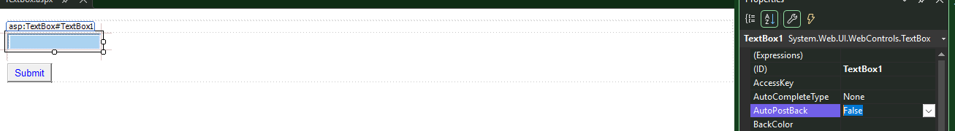
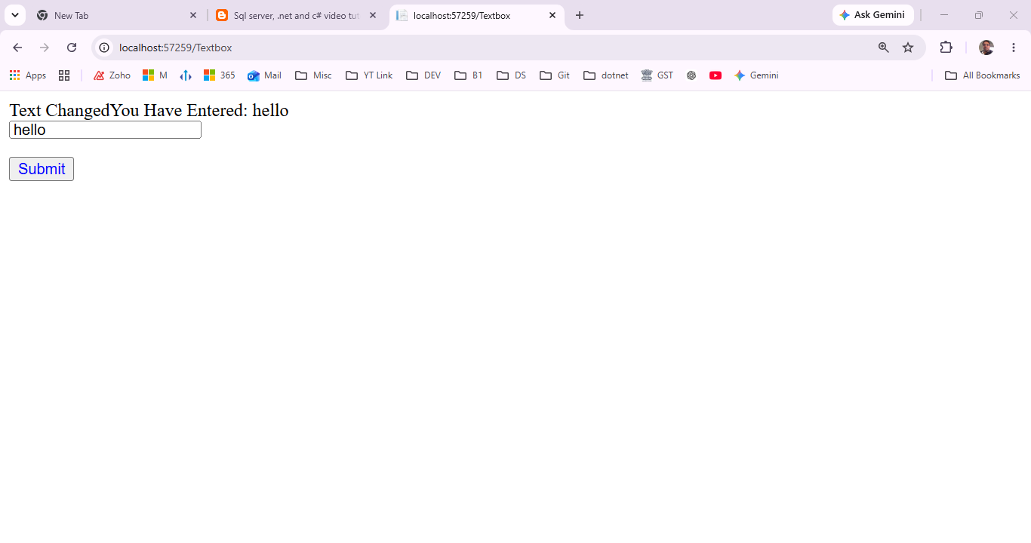
If auto response true ---immediate response
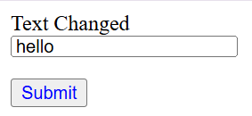
Text Box Focus
Cursor blinking on second textbox
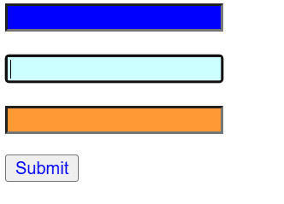
protected void Page_Load(object sender, EventArgs e)
{
TextBox1.Focus(); // Set focus to the TextBox when the page loads
TextBox2.Focus(); //only the last focus will work
}
<%@ Page Language="C#" AutoEventWireup="true" CodeBehind="Textbox.aspx.cs" Inherits="WebForm1.Textbox" %>

<!DOCTYPE html>

<html xmlns="http://www.w3.org/1999/xhtml">
<head runat="server">
<title></title>
</head>
<body>
<form id="form1" runat="server">
<div>
</div>
<asp:TextBox ID="TextBox1" runat="server" BackColor="Blue" Height="16px" OnTextChanged="TextBox1_TextChanged" Rows="1" ToolTip="First Name"></asp:TextBox>
<br />
<br />
<asp:TextBox ID="TextBox2" runat="server" BackColor="#CCFFFF" Height="16px" OnTextChanged="TextBox1_TextChanged" Rows="1" ToolTip="Middle Name"></asp:TextBox>
<br />
<br />
<asp:TextBox ID="TextBox3" runat="server" BackColor="#FF9933" Height="16px" OnTextChanged="TextBox1_TextChanged" Rows="1" ToolTip="Last Name"></asp:TextBox>
<p>
<asp:Button ID="Button1" runat="server" ForeColor="Blue" Text="Submit" OnClick="Button1_Click" />
</p>
</form>
</body>
</html>

ASP.NET Radio Button Control - Part 11
Radio Button control is used, when you want the user to select only one option from the available choices. For example, the gender of a person. A person can be Male or Female. He cannot be both. So, if the user has first selected Male, and if tries to select Female, the initial Male selection he made should automatically get de-selected. Another example, would be when you want the user to select his or her favourite colour.
In short, if you want to provide the user with mutually exclusive options, then choose a Radio Button Control.
Important Properties of the Radio Button Control
Checked - This is a boolean property, that is used to check if the button is checked or not.
Text - This is string property used to get or set the text associated with the radio button control
TextAlign - right or left. On which side of the radio button the text should appear
AutoPostBack - Set this property to true, if you want the webform to be posted immediately when the checked status of the radio button changes.
Group Name - By default, the individual radio button selections, are not mutually exclusive. If you have a group of radio buttons, and if you want the selections among the group to be mutually exclusive, then use the same group name for all the radio button controls.
Events:
CheckedChanged - This event is fired when the checked status of the radio button control is changed.

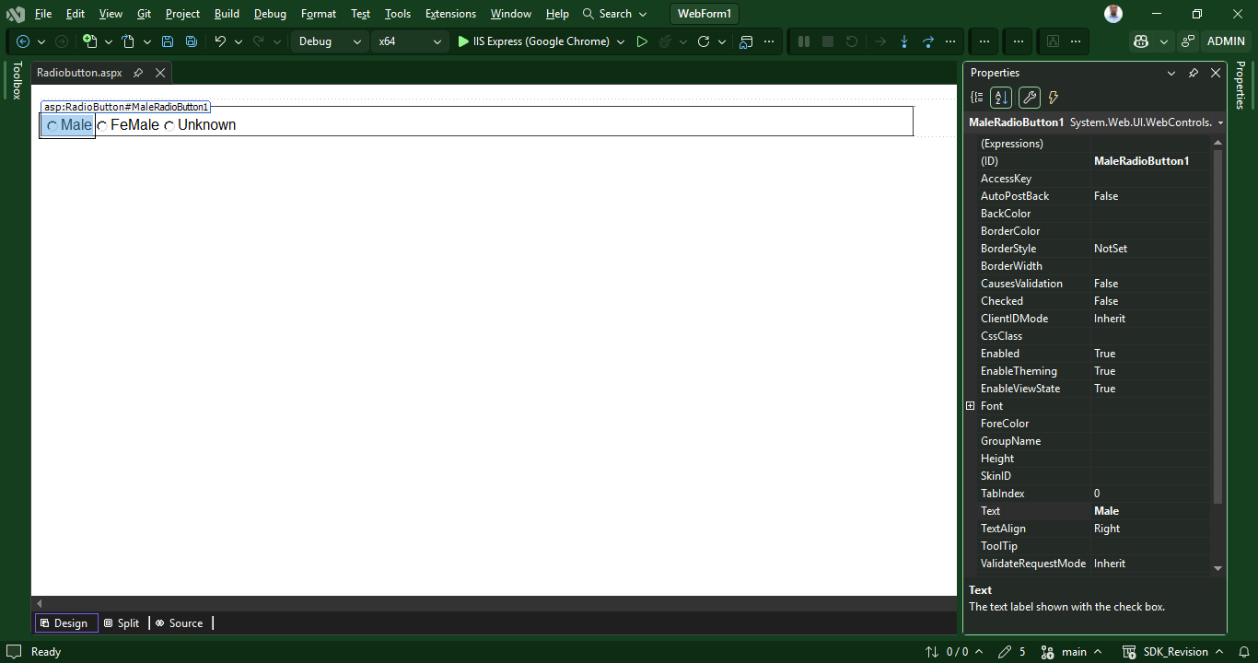

<%@ Page Language="C#" AutoEventWireup="true" CodeBehind="Radiobutton.aspx.cs" Inherits="WebForm1.Radiobutton" %>
<!DOCTYPE html>
<html xmlns="http://www.w3.org/1999/xhtml">
<head runat="server">
<title></title>
</head>
<body>
<form id="form1" runat="server">
<div style="font-family: Arial">
<fieldset style="width:300px">
<legend>Gender</legend>
<asp:RadioButton ID="MaleRadioButton1" Text = “Male” runat="server" />
<asp:RadioButton ID="FemaleRadioButton2" Text = “Female” runat="server" />
<asp:RadioButton ID="UnknownRadioButton3" Text = “Unknown” runat="server" />
</fieldset>
</div>
</form>
</body>
</html>

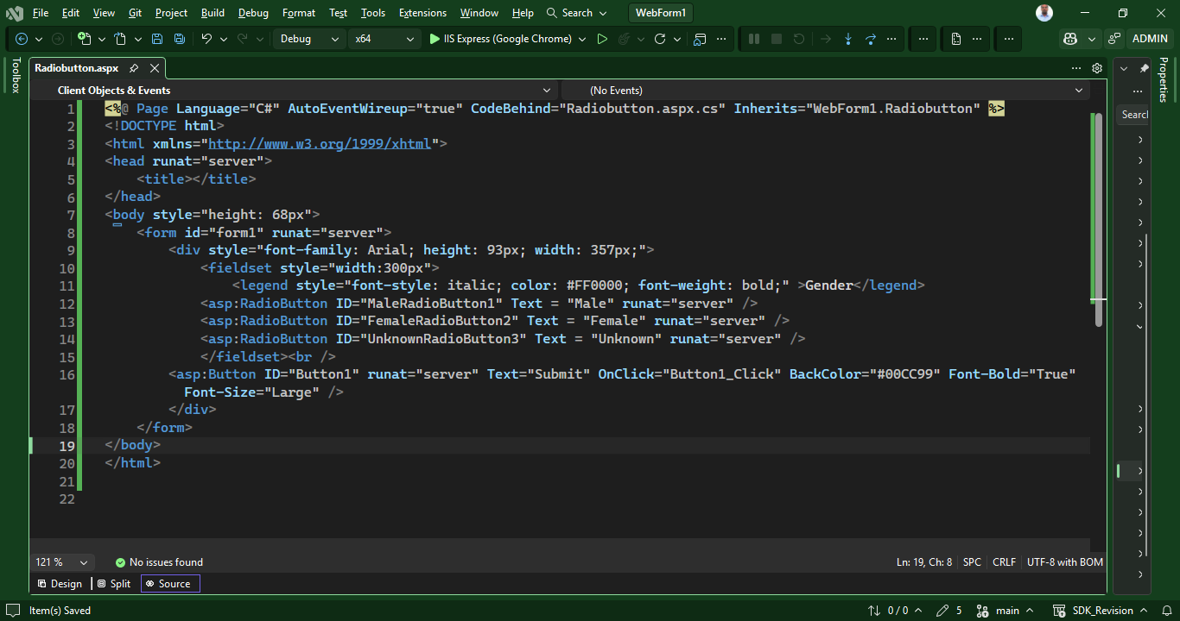
<%@ Page Language="C#" AutoEventWireup="true" CodeBehind="Radiobutton.aspx.cs" Inherits="WebForm1.Radiobutton" %>
<!DOCTYPE html>
<html xmlns="http://www.w3.org/1999/xhtml">
<head runat="server">
<title></title>
</head>
<body style="height: 68px">
<form id="form1" runat="server">
<div style="font-family: Arial; height: 93px; width: 357px;">
<fieldset style="width:300px">
<legend style="font-style: italic; color: #FF0000; font-weight: bold;" >Gender</legend>
<asp:RadioButton ID="MaleRadioButton1" Text = "Male" runat="server" />
<asp:RadioButton ID="FemaleRadioButton2" Text = "Female" runat="server" />
<asp:RadioButton ID="UnknownRadioButton3" Text = "Unknown" runat="server" />
</fieldset><br />
<asp:Button ID="Button1" runat="server" Text="Submit" OnClick="Button1_Click" BackColor="#00CC99" Font-Bold="True" Font-Size="Large" />
</div>
</form>
</body>
</html>
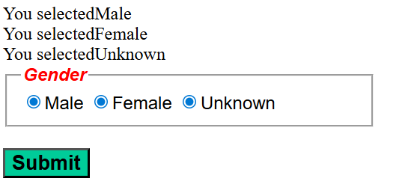

Button Click Event
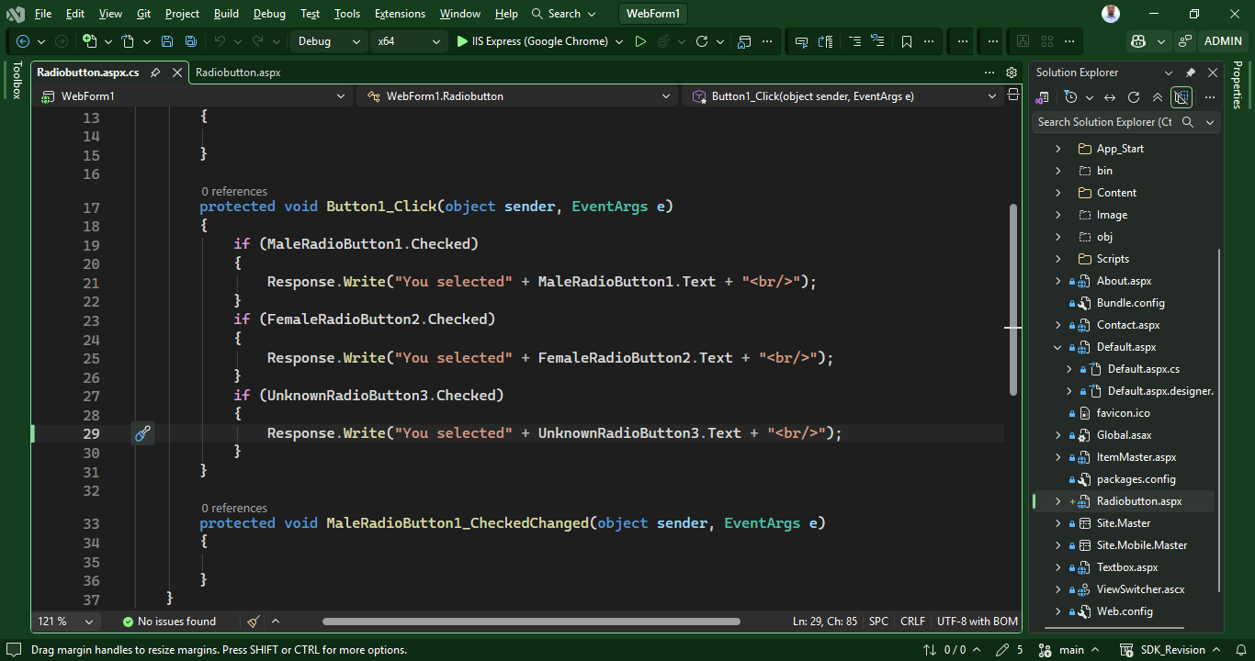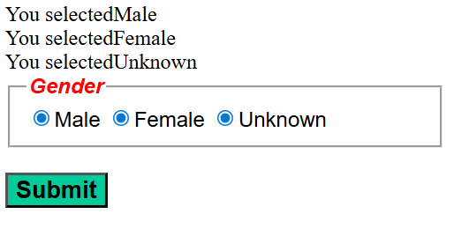
Radio Button Group
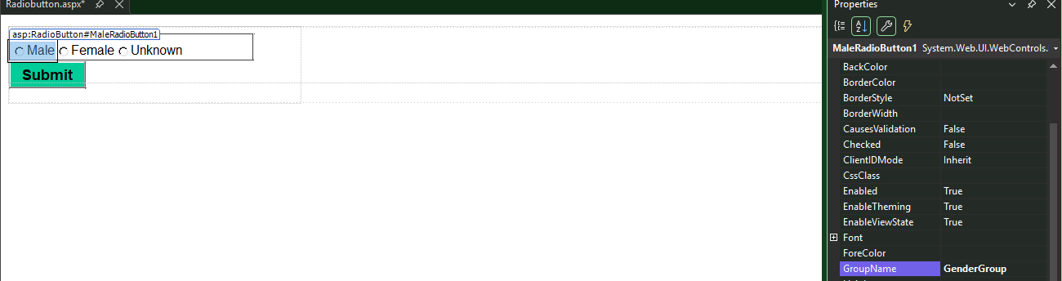

Now only one radio button
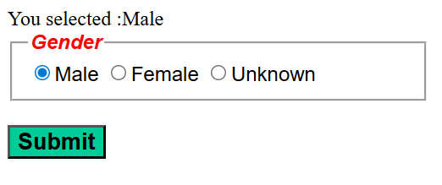
Another method to define grouping using html code
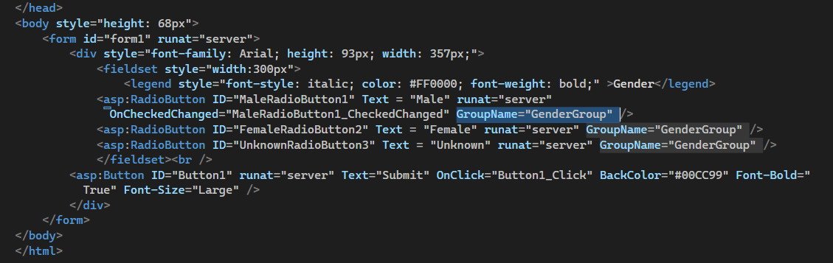
Improve code for performance
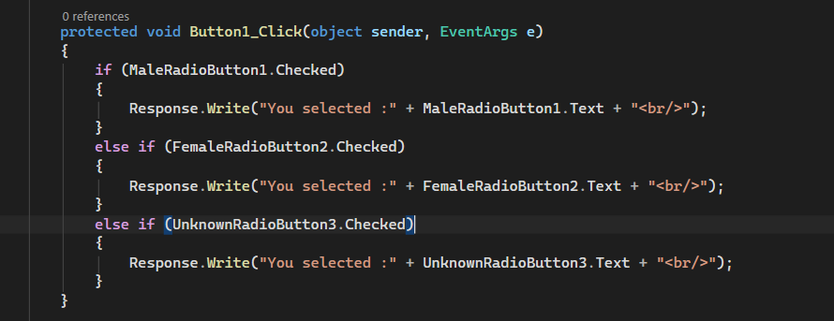
Or
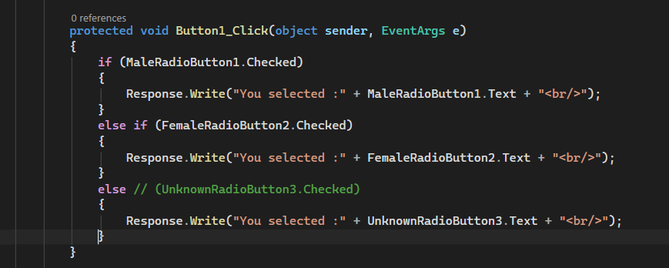

ASP.NET CheckBox Control - Part 12

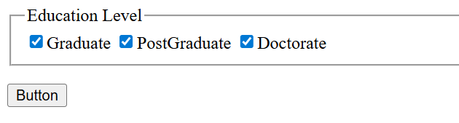
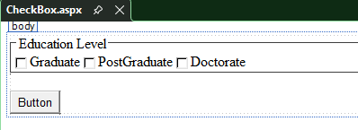

<!DOCTYPE html>
<html xmlns="http://www.w3.org/1999/xhtml">
<head runat="server">
<title></title>
</head>
<body>
<form id="form1" runat="server">
<div>
<fieldset style="width:300px">
<legend><b>Education Level</b></legend>
<asp:CheckBox ID="CheckBox1" runat="server" OnCheckedChanged="CheckBox1_CheckedChanged" Text="Graduate" />
<asp:CheckBox ID="CheckBox2" Text="Post Graduate" runat="server" />
<asp:CheckBox ID="CheckBox3" Text="Doctorate" runat="server" />
</fieldset>
</div>
<p>
<asp:Button ID="Button1" runat="server" Text="Button" Font-Bold="True"/>
</p>
</form>
</body>

Click even generate only one check mark as output

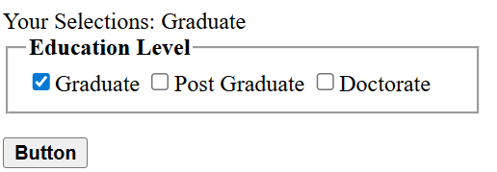
using System;
using System.Collections.Generic;
using System.Linq;
using System.Web;
using System.Web.UI;
using System.Web.UI.WebControls;
using System.Text;

namespace WebForm1
{
public partial class CheckBox : System.Web.UI.Page
{
protected void Page_Load(object sender, EventArgs e)
{
}
protected void CheckBox1_CheckedChanged(object sender, EventArgs e)
{
}
protected void Button1_Click(object sender, EventArgs e)
{
StringBuilder sbUserChoices = new StringBuilder();
if (CheckBox1.Checked)
{
sbUserChoices.Append(CheckBox1.Text);
}
else if (PostGraduateCheckBox.Checked)
{
sbUserChoices.Append(PostGraduateCheckBox.Text);
}
else if (DoctorateCheckBox.Checked)
{
sbUserChoices.Append(DoctorateCheckBox.Text);
}
Response.Write("Your Selections: " + sbUserChoices.ToString());
}
}
}

Auto check box focus

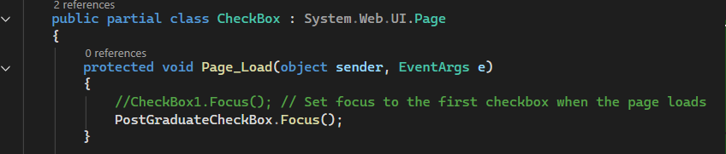
Another method
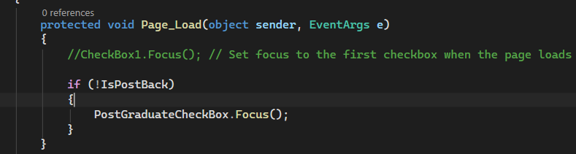
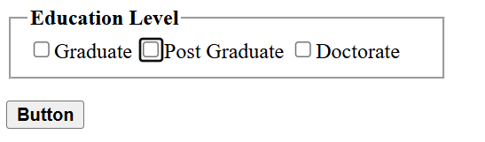
As soon as page load checkbox click
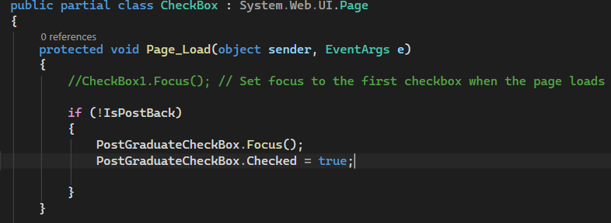
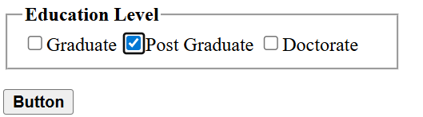
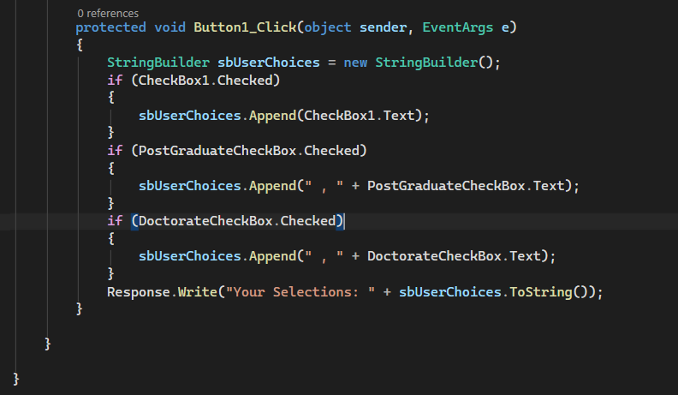

ASP.NET Hyperlink control - Part 13

The ASP.NET Hyperlink control is used to create a link to another Web page.
Properties:
Text - The link text that will be shown to the user
Navigate URL - The URL of the page to which the user will be sent
ImageURL - The URL of the image, that will be displayed for the link. If you specify both the Text and ImageUrl, the image will be displayed instead of the text. If for some reason, the image is not unavailable, the text will be displayed.
Target - If target is not specified, the web page to which the hyperlink is linked, will be displayed in the same window. If you set the Target to _blank, the web page will be opened in a new window.
Methods:
Focus() - Call this method to Set the input focus when the page loads.
Events:
No HyperLink control specific events

Click on Navigate url and put value
Text = Github Link

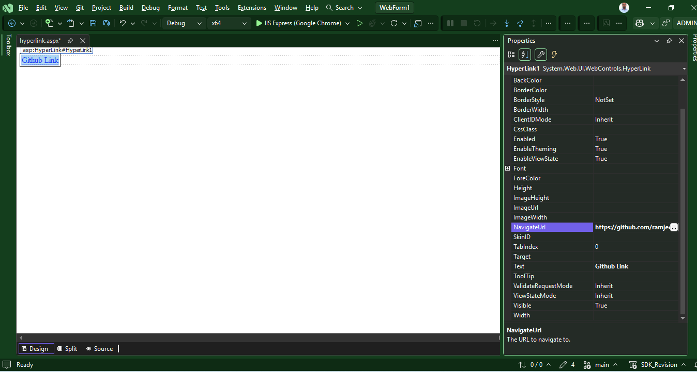
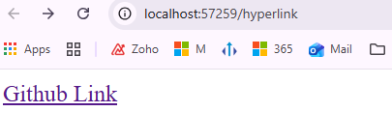
We can link all the web form inside the system after clicking navigateurl
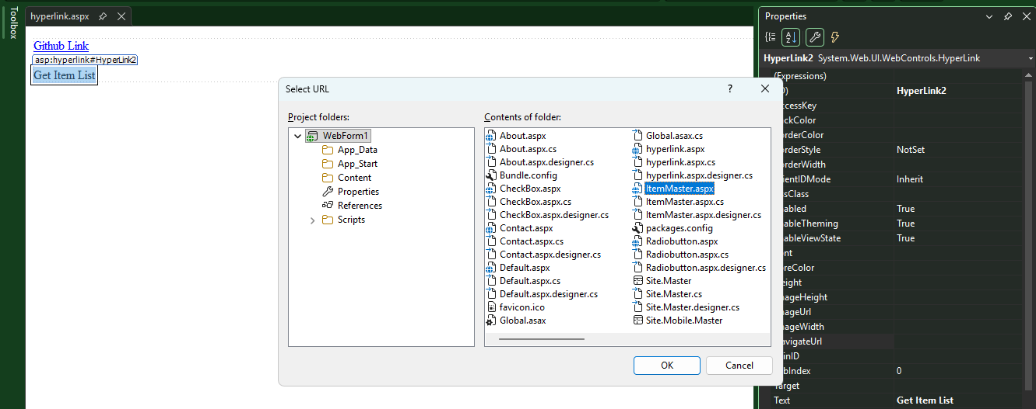
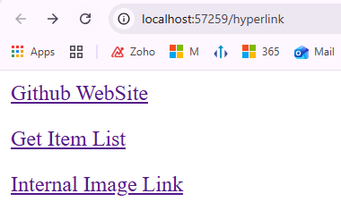

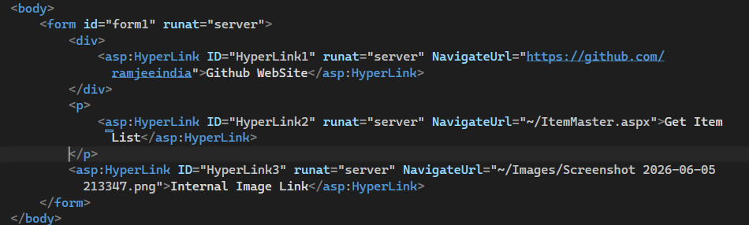
The above link open in same tab let render one another tab
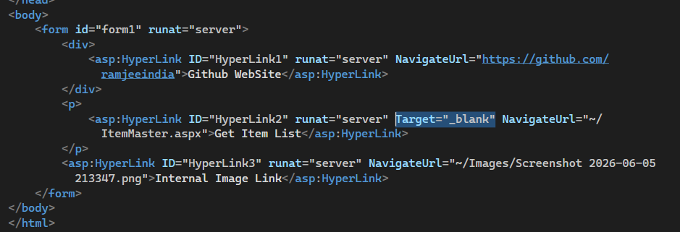

Focus on Hyperlink after page load
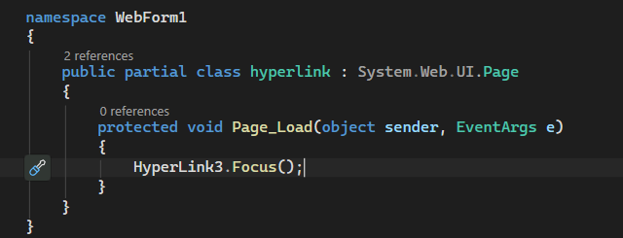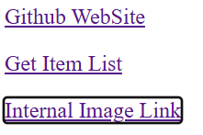
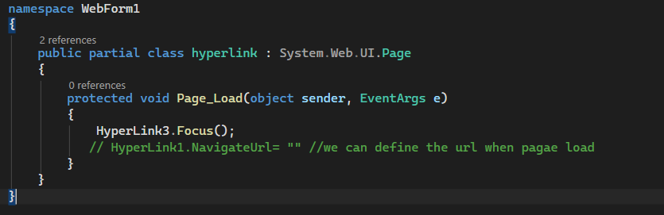

ASP.NET Button, LinkButton and ImageButton Controls - Part 14
The Button, LinkButton and ImageButton controls in ASP.NET are used to post a page to the server.
1. Button - The Button control is used to display a push button. Use the Text property to change the Text on the Button control.
2. LinkButton - LinkButton displays the button like a HyperLink. Use the Text property to change the LinkText.
3. ImageButton - ImageButton provides the flexibility of associating an Image with the button, using the ImageURL property.
All the 3 button controls support CommandName and CommandArgument properties. We will talk about these properties in the next video session. These 3 button controls also support CuasesValidation and ValidationGroup properties. We will discuss about these properties, when we talk about validation controls in asp.net. We will discuss about PostBackURL property, when we talk about cross page post back.

Associate Image with Image button – click on image url and select file
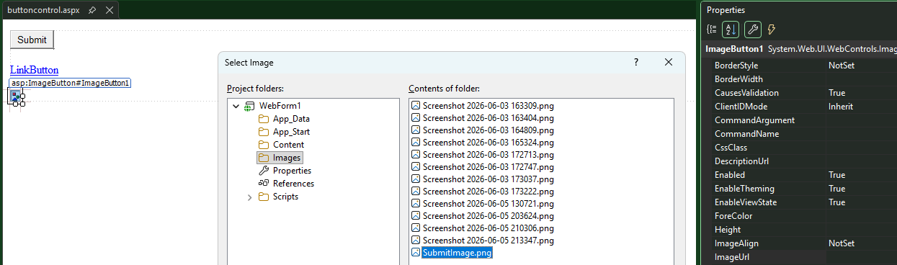
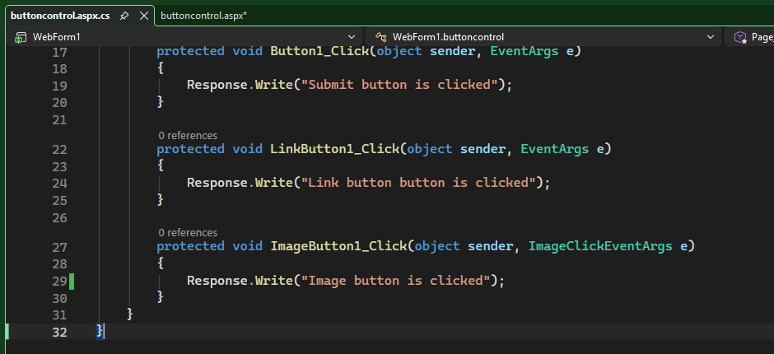
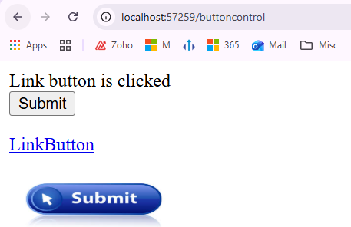
Onclientclick using alert function
alert('You are about to Sumit the Image')
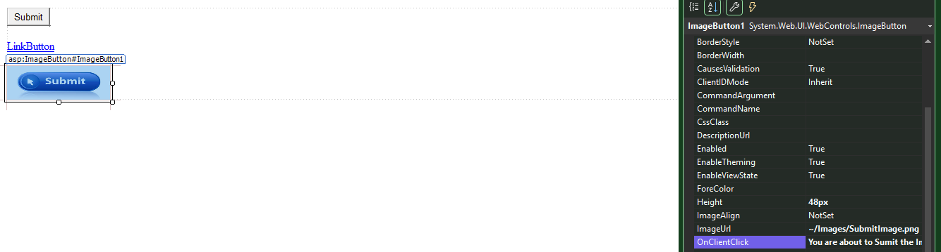
Write JavaScript to button control event

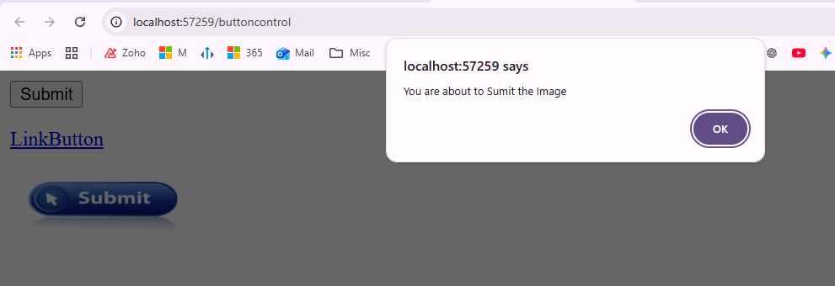
<html xmlns="http://www.w3.org/1999/xhtml">
<head runat="server">
<title></title>
</head>
<body>
<form id="form1" runat="server">
<div>
<asp:Button ID="Button1" Text="Submit" runat="server" OnClick="Button1_Click" OnClientClick="alert('You are about to Sumit ')" />
</div>
<p>
<asp:LinkButton ID="LinkButton1" runat="server" OnClick="LinkButton1_Click">LinkButton</asp:LinkButton>
</p>
<p>
<asp:ImageButton ID="ImageButton1" runat="server" Height="48px" ImageUrl="~/Images/SubmitImage.png" OnClick="ImageButton1_Click" OnClientClick="alert('You are about to Sumit the Image')" Width="146px" />
</p>
</form>
</body>
</html>

Another button in JavaScript you can cancel
Confirm function in linkbutton
OnClientClick="confirm('You are about to Sumit the LinkButton ?');"

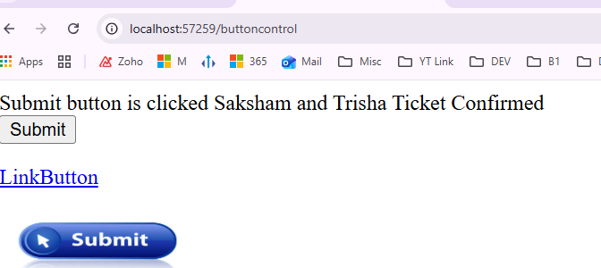

Command Event of an asp.net button control - Part 15
ASP.NET button control exposes 2 events - Click and Command events. In this session we will discuss about the Command event. When the Button is clicked, both the events are raised. Click event happens before the Command event.
To prove this drag and drop a button control onto the webform
1. Double click the Button control. This will automatically generate the click event handler in the code behind file
2. To generate the command event handler, right click the button control and select properties. Click the events icon, in the properties window. Double click on the command event. The event handler for the command event should now be generated.
If you are following along with me. At this stage the HTML for the button control in the aspx page, should look as shown below.
<asp:Button ID="Button1" runat="server" Text="Button" onclick="Button1_Click"
CommandName="Button1" oncommand="Button1_Command" />
Please copy and paste the following code in the code behind file.
protected void Button1_Click(object sender, EventArgs e)
{
Response.Write("Button1 Click event handled <br/>");
}
protected void Button1_Command(object sender, CommandEventArgs e)
{
Response.Write("Button1 Command event handled <br/>");
}
When you click the Button now, you should see the following output. This proves that when a button is clicked, first the Click event and then the Command event is fired.
Button1 Click event handled
Button1 Command event handled
The click event handler and the command event handlers, are attached to the respective Click and Command events in the HTML using onclick and oncommand attributes. The event handlers can also be attached programatically as shown below.
protected void Page_Load(object sender, EventArgs e)
{
Button1.Click += new EventHandler(Button1_Click);
Button1.Command += new CommandEventHandler(Button1_Command);
}
Note: Eventhandlers can be associated to the events of a control in 2 ways.
1. Declaratively at design time in the HTML
2. Programatically using delegates
If you have multiple button controls on a webform, and if you want to programmatically determine which Button control is clicked, we can make use of Command event, along with CommandName and CommandArgument properties. Command event, makes it possible to have a single event handler method responding to the click event of multiple buttons. The command event, CommandName and CommandArgument properties are extremely useful when working with data-bound controls like Repeater, GridView, DataList. We will discuss about Repeater, GridView, and DataList in a later video session.
Let's understand this with an example. Consider the HTML below. Here we have 4 buttons. Notice that all the button controls have the same command event handler method - oncommand="CommandButton_Click". Also, notice the CommandName and CommandArgument properties. We will later use these properties, in the code behind to determine which button is clicked.
<asp:Button ID="PrintButton" runat="server" Text="Print" oncommand="CommandButton_Click" CommandName="Print"/>
<asp:Button ID="DeletButton" runat="server" Text="Delete" oncommand="CommandButton_Click" CommandName="Delete"/>
<asp:Button ID="Top10Button" runat="server" Text="Show Top 10 Employees" oncommand="CommandButton_Click"
CommandName="Show" CommandArgument="Top10"/>
<asp:Button ID="Bottom10Button" runat="server" Text="Show Bottom 10 Employees" oncommand="CommandButton_Click"
CommandName="Show" CommandArgument="Bottom10"/>
<asp:Label ID="OutputLabel" runat="server"></asp:Label>
Copy and Paste the following code in your code behind file. The CommandEventArgs object, has the CommandName and CommandArgument properties, that are used to programatically determine which button the user has clicked.
protected void CommandButton_Click(object sender, CommandEventArgs e)
{
switch (e.CommandName)
{
case "Print":
OutputLabel.Text = "You clicked Print Button";
break;
case "Delete":
OutputLabel.Text = "You clicked Delete Button";
break;
case "Show":
if (e.CommandArgument.ToString() == "Top10")
{
OutputLabel.Text = "You clicked Show Top 10 Employees Button";
}
else
{
OutputLabel.Text = "You clicked Show Bottom 10 Employees Button";
}
break;
default:
OutputLabel.Text = "We don't know which button you clicked";
break;
}
}

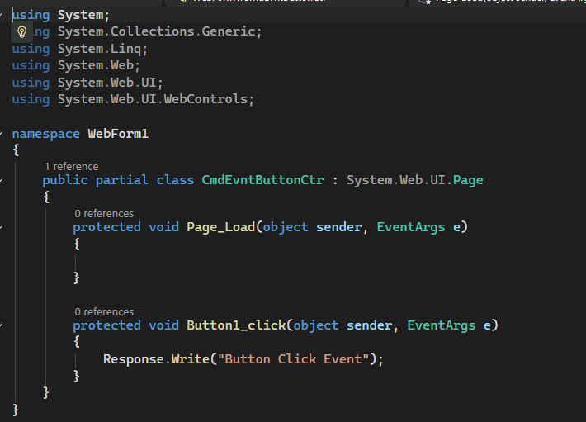
All types of events showing after Click on Button Properties then
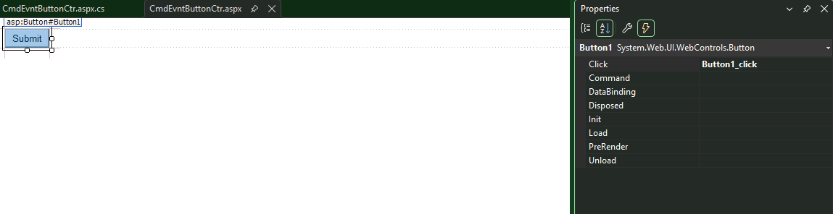

If we want to generate command event double click on Command Line Property then
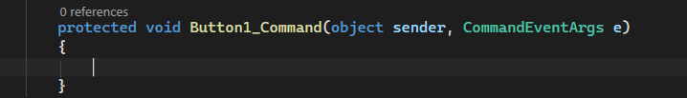
Same time message appears both event
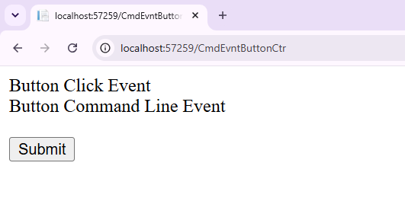

The above event handed by html attribute
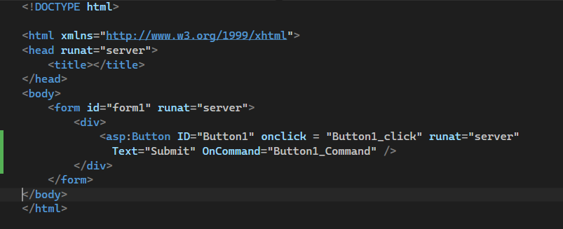

But if remove the attribute and handle the event using command line then

Another method
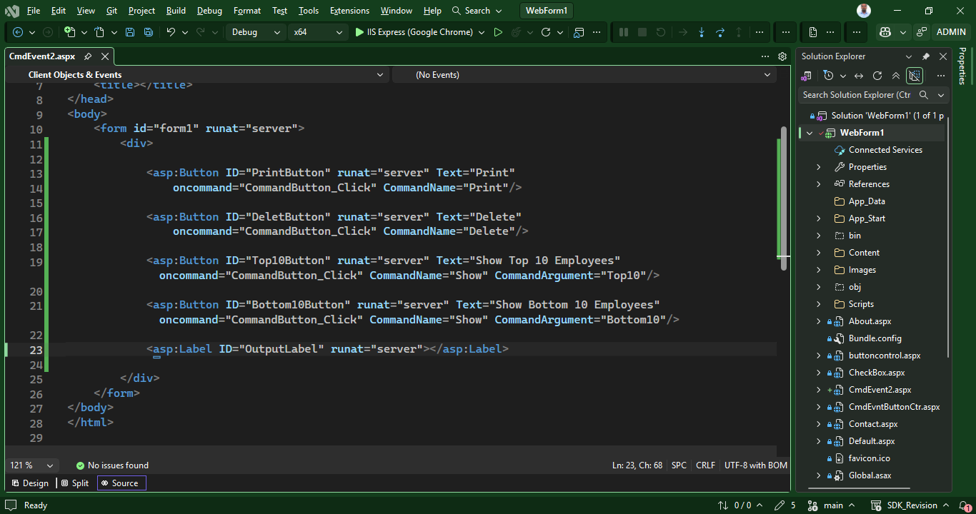
Command name uses >>>>>

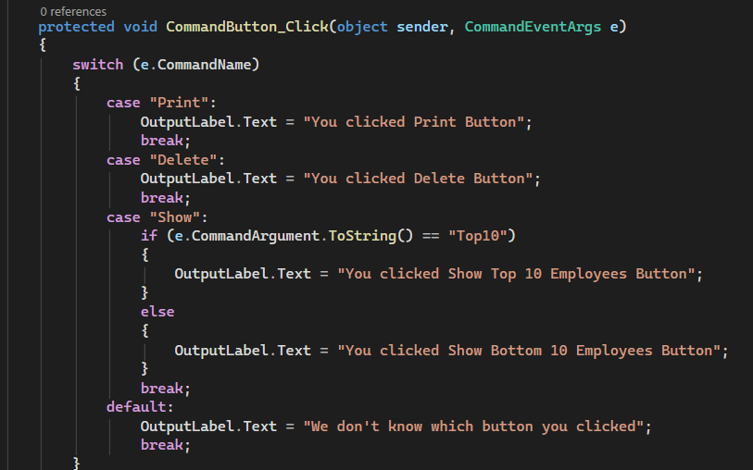
using System;
using System.Collections.Generic;
using System.Linq;
using System.Web;
using System.Web.UI;
using System.Web.UI.WebControls;

namespace WebForm1
{
public partial class CmdEvent2 : System.Web.UI.Page
{
protected void Page_Load(object sender, EventArgs e)
{

}

protected void CommandButton_Click(object sender, CommandEventArgs e)
{
switch (e.CommandName)
{
case "Print":
OutputLabel.Text = "You clicked Print Button";
break;
case "Delete":
OutputLabel.Text = "You clicked Delete Button";
break;
case "Show":
if (e.CommandArgument.ToString() == "Top10")
{
OutputLabel.Text = "You clicked Show Top 10 Employees Button";
}
else
{
OutputLabel.Text = "You clicked Show Bottom 10 Employees Button";
}
break;
default:
OutputLabel.Text = "We don't know which button you clicked";
break;
}

}
}
}
Dropdownlist in asp.net - Part 16

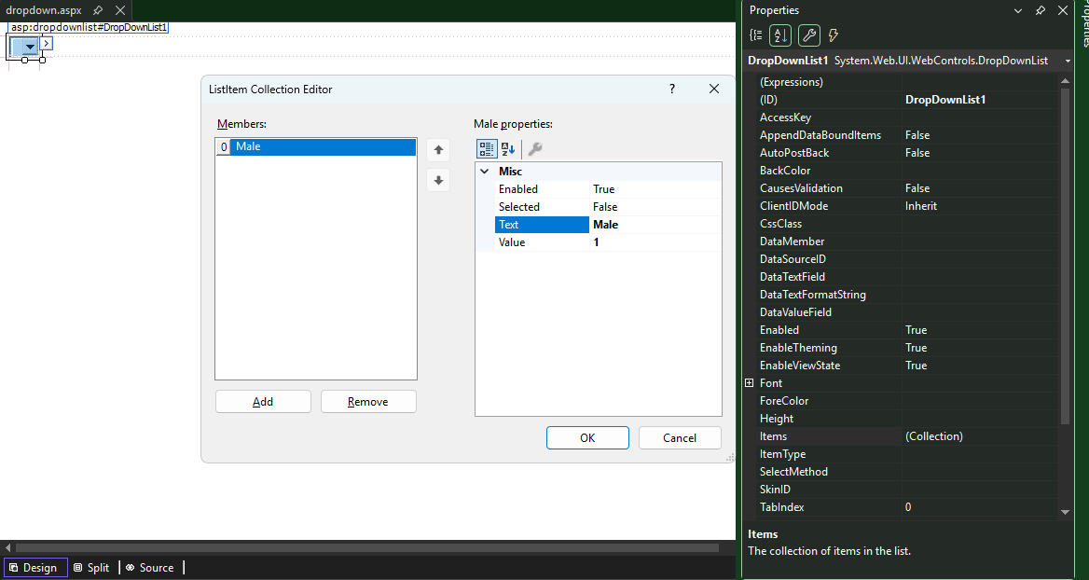
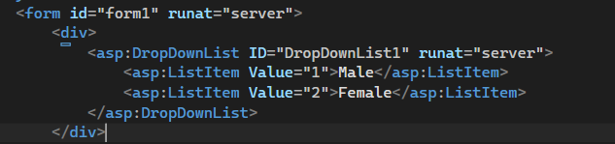
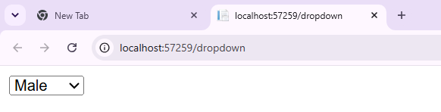

List item has another property selected that will be auto selected
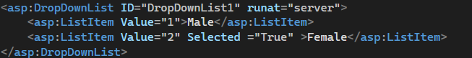
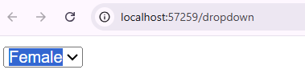
Another property enabled
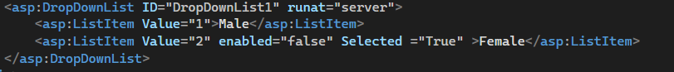
Only one showing
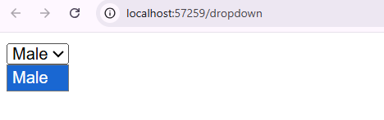
Dropdown creation using program
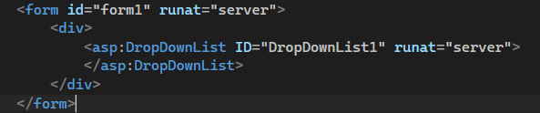

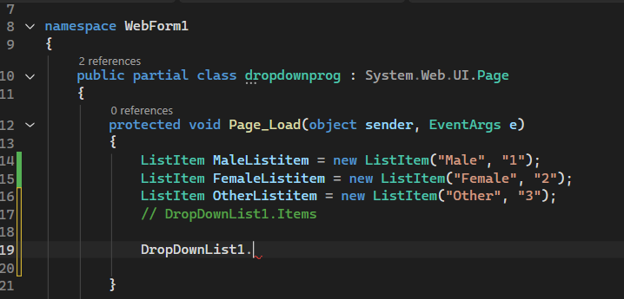
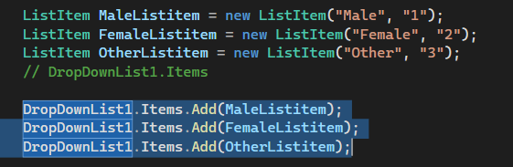
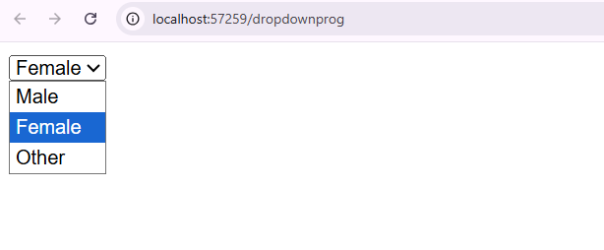
LET ADD BUTTON CONTROL
WHEN click on button same will be repeat after click

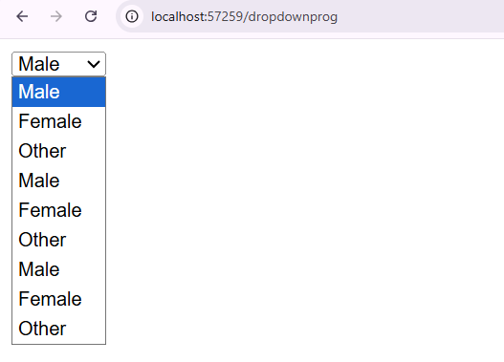
This method retunthe value only one times
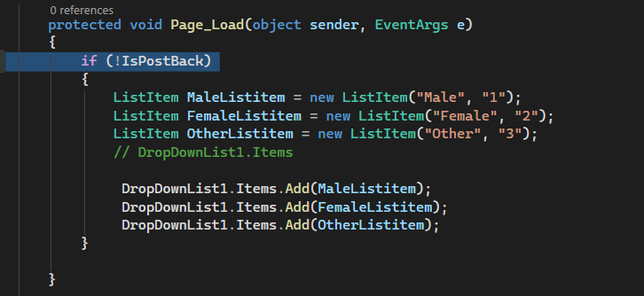
Data bind asp.net dropdownlist with data from the database - Part 17
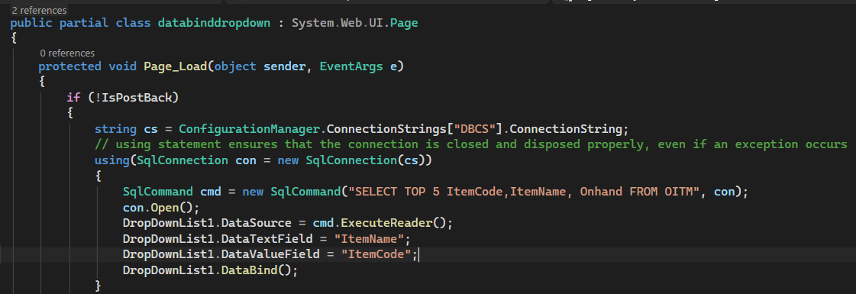
WE CAN DEFINE THE DATA FIELD IN HTML CODE
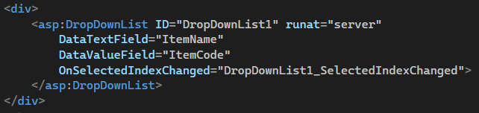
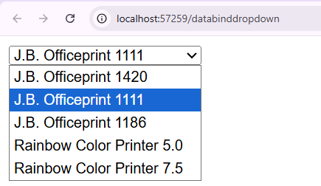
Binding an asp.net dropdownlist with an XML file - Part 18
Add xml file
Click on project >>>add > new item >>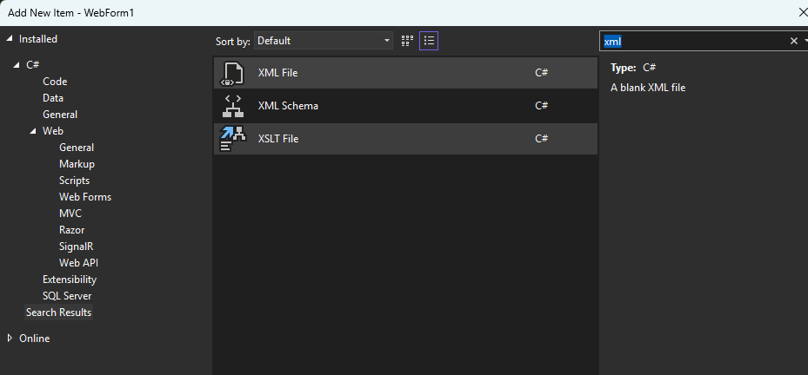
The code for map xml file
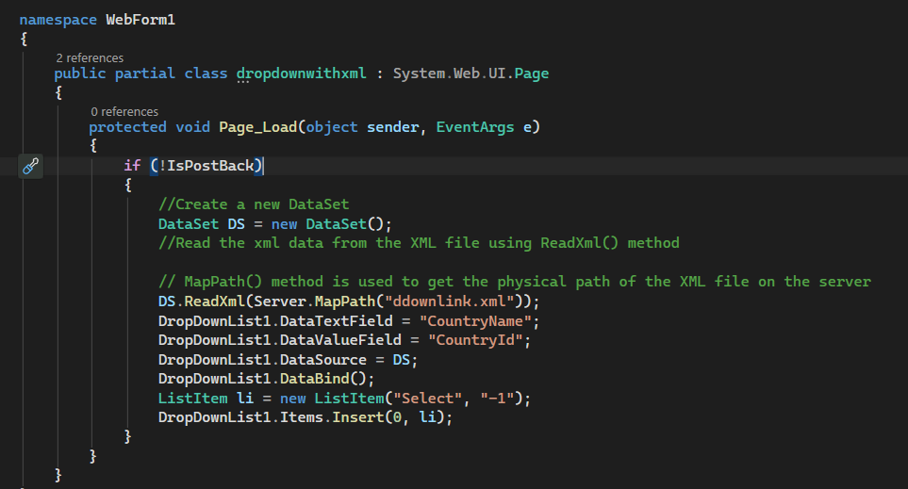

19.Virtual Path and Physical Path

If we click on web app and open in browser that is called as virtual path
https://localhost:44326/PageinRootDirectory
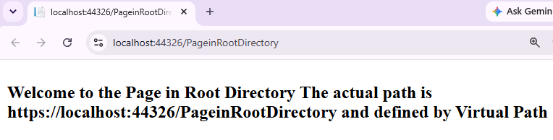
To understand the physical path lets create Folder as Categories > Electronics > Pageinelectronics
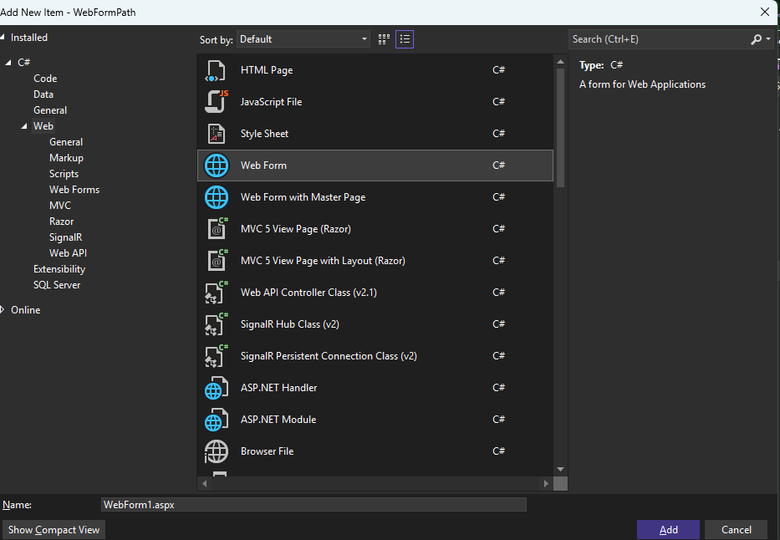
Another master folder masterdata > countries > country.xml
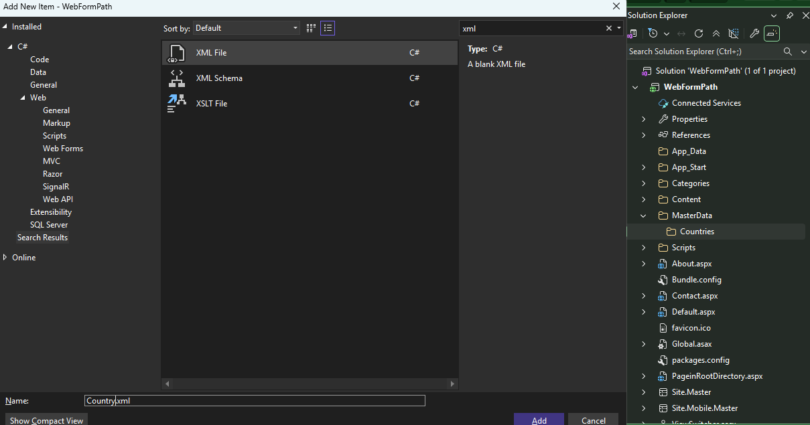
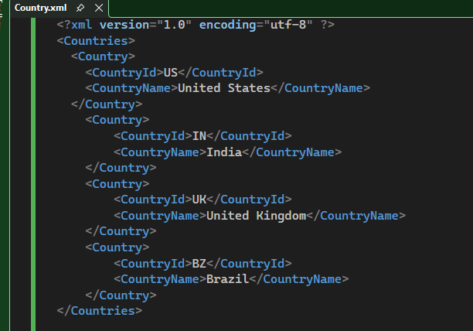
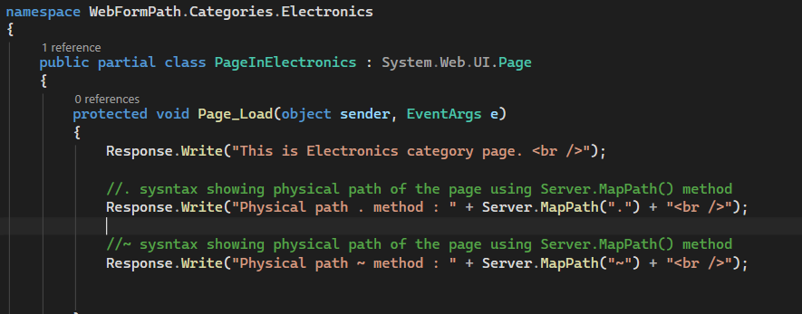
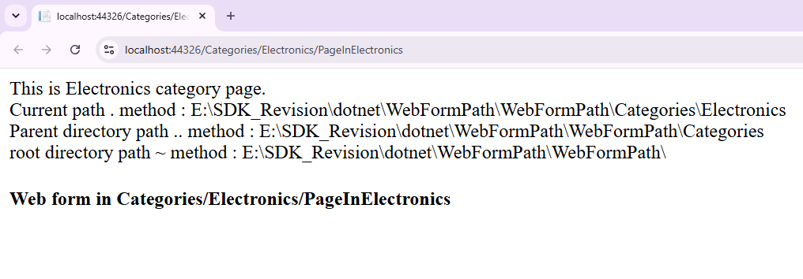
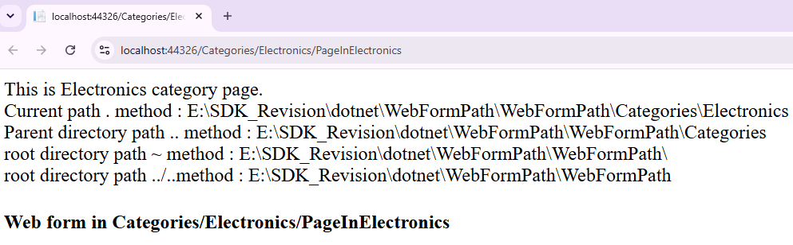
protected void Page_Load(object sender, EventArgs e)
{
Response.Write("This is Electronics category page. <br />");

//. sysntax showing current path of the page using Server.MapPath(.) method
Response.Write("Current path . method : " + Server.MapPath(".") + "<br />");

//. sysntax showing Parent directory of the page using Server.MapPath(..) method
Response.Write("Parent directory path .. method : " + Server.MapPath("..") + "<br />");

//~ sysntax showing root directory path of the page using Server.MapPath(~) method
Response.Write("root directory path ~ method : " + Server.MapPath("~") + "<br />");
//../.. another method for root directory
Response.Write("root directory path ../..method : " + Server.MapPath("..//..") + "<br />");
}

Main page path does not support .. method bcz that is already in main directory
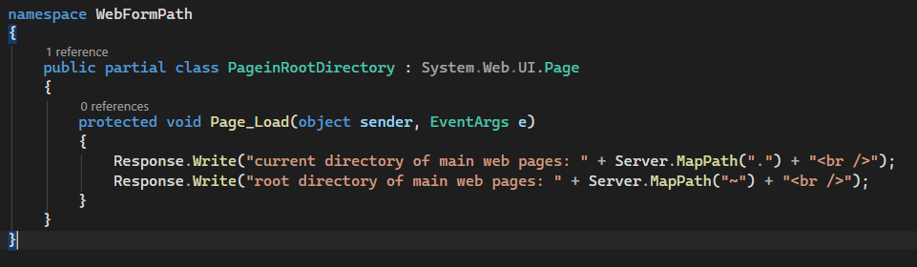
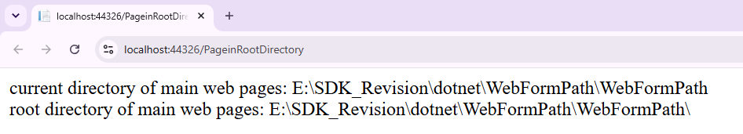
20 Mapping virtual path to physical path using Server MapPath method Example
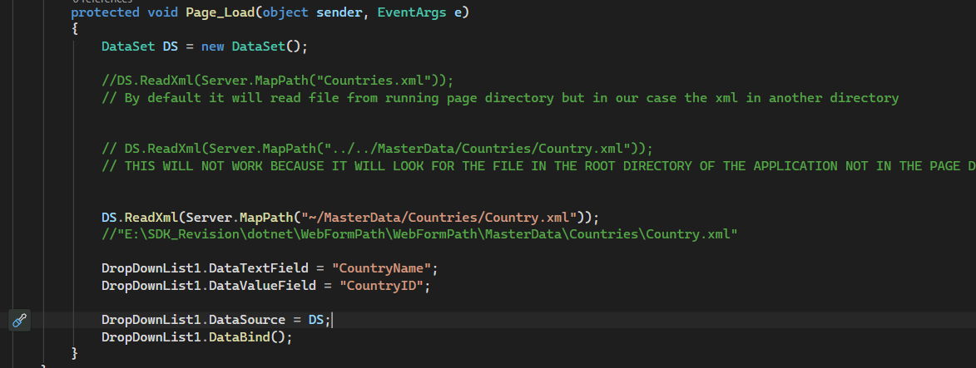

21. Select Data from Dropdown List
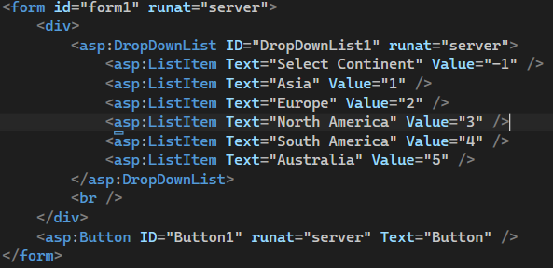
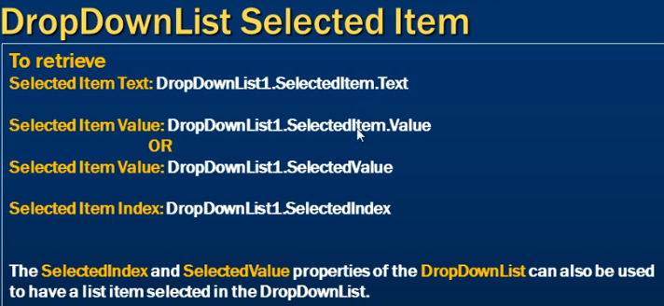
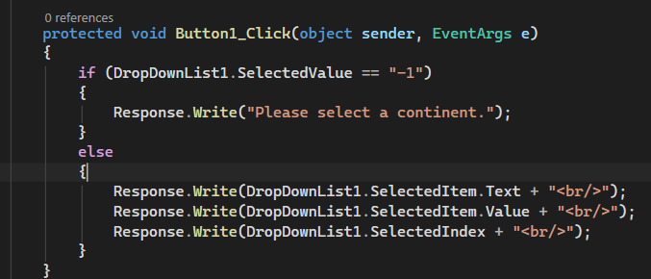

When select button clicked then
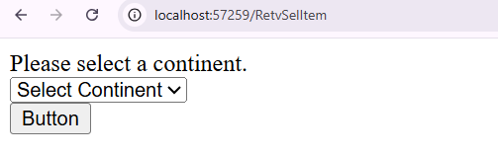
Another output
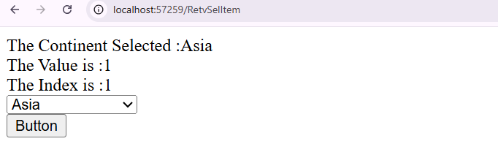
22. Cascading
First create the required tables and populate them, with some sample data using the SQL script below.
Create Table tblContinents
(
ContinentId int identity primary key,
ContinentName nvarchar(50)
)
Insert into tblContinents values ('Asia')
Insert into tblContinents values ('Europe')
Insert into tblContinents values ('South America')
Create Table tblCountries
(
CountryId int identity primary key,
CountryName nvarchar(50),
ContinentId int foreign key references dbo.tblContinents(ContinentId)
)
Insert into tblCountries values ('India', 1)
Insert into tblCountries values ('Japan', 1)
Insert into tblCountries values ('Malaysia', 1)
Insert into tblCountries values ('United Kingdom', 2)
Insert into tblCountries values ('France', 2)
Insert into tblCountries values ('Germany', 2)
Insert into tblCountries values ('Argentina', 3)
Insert into tblCountries values ('Brazil', 3)
Insert into tblCountries values ('Colombia', 3)
Create Table tblCities
(
CityId int identity primary key,
CityName nvarchar(50),
CountryId int foreign key references dbo.tblCountries(CountryId)
)
Insert into tblCities values ('Bangalore', 1)
Insert into tblCities values ('Chennai', 1)
Insert into tblCities values ('Mumbai', 1)
Insert into tblCities values ('Tokyo', 2)
Insert into tblCities values ('Hiroshima', 2)
Insert into tblCities values ('Saku', 2)
Insert into tblCities values ('Kuala Lumpur', 3)
Insert into tblCities values ('Ipoh', 3)
Insert into tblCities values ('Tawau', 3)
Insert into tblCities values ('London', 4)
Insert into tblCities values ('Manchester', 4)
Insert into tblCities values ('Birmingham', 4)
Insert into tblCities values ('Paris', 5)
Insert into tblCities values ('Cannes', 5)
Insert into tblCities values ('Nice', 5)
Insert into tblCities values ('Frankfurt', 6)
Insert into tblCities values ('Eutin', 6)
Insert into tblCities values ('Alsfeld', 6)
Insert into tblCities values ('Rosario', 7)
Insert into tblCities values ('Salta', 7)
Insert into tblCities values ('Corrientes', 7)
Insert into tblCities values ('Rio de Janeiro', 8)
Insert into tblCities values ('Salvador', 8)
Insert into tblCities values ('Brasília', 8)
Insert into tblCities values ('Cali', 9)
Insert into tblCities values ('Montería', 9)
Insert into tblCities values ('Bello', 9)
Create procedure spGetContinents
as
Begin
Select ContinentId, ContinentName from tblContinents
End
Create procedure spGetCountriesByContinentId
@ContinentId int
as
Begin
Select CountryId, CountryName from tblCountries
where ContinentId = @ContinentId
End
Create procedure spGetCitiesByCountryId
@CountryId int
as
Begin
Select CityId, CityName from tblCities
where CountryId = @CountryId
End

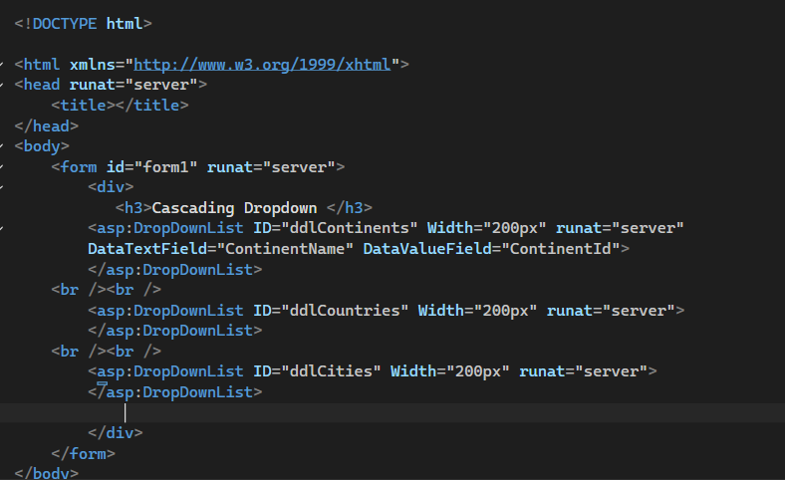
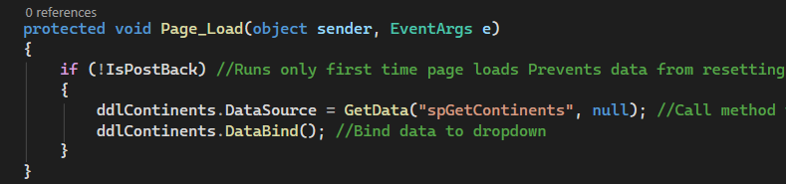
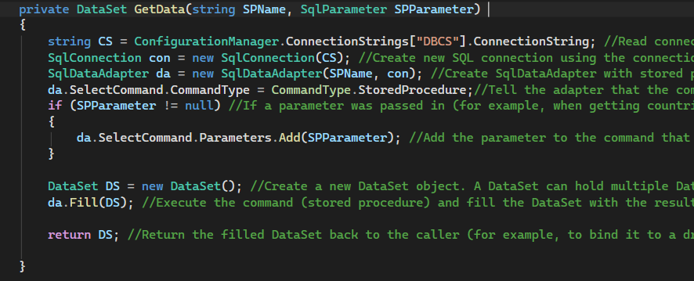
Output
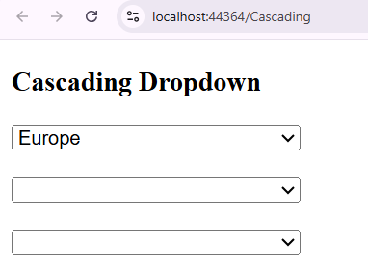
Output -- the web page will show Select Continent after page load
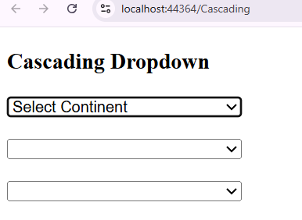
Same method for another dropdown
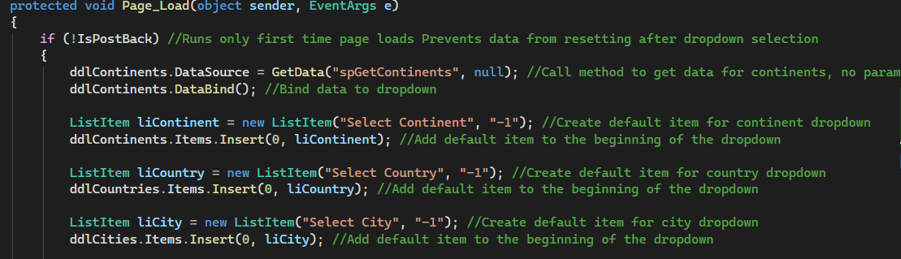
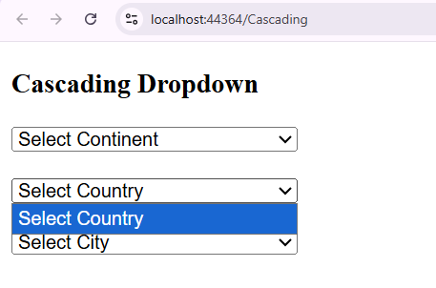
We have to disable the dropdown 2 and 3 when page load
Output will be
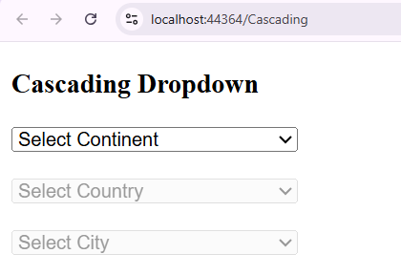
Now if we select the first dropdown then dropdown should be enable

